HB& HARRINGTON BLUE & PARTNERS
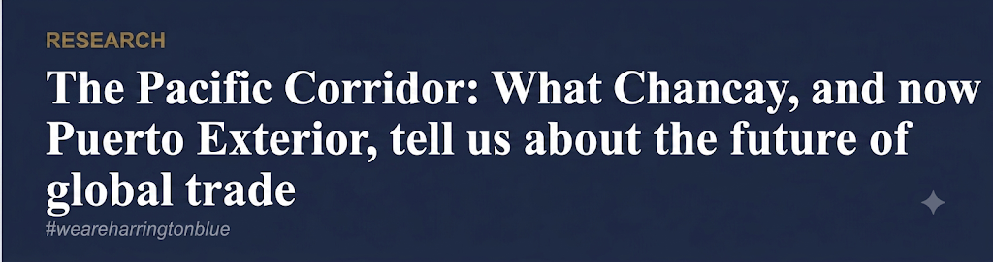
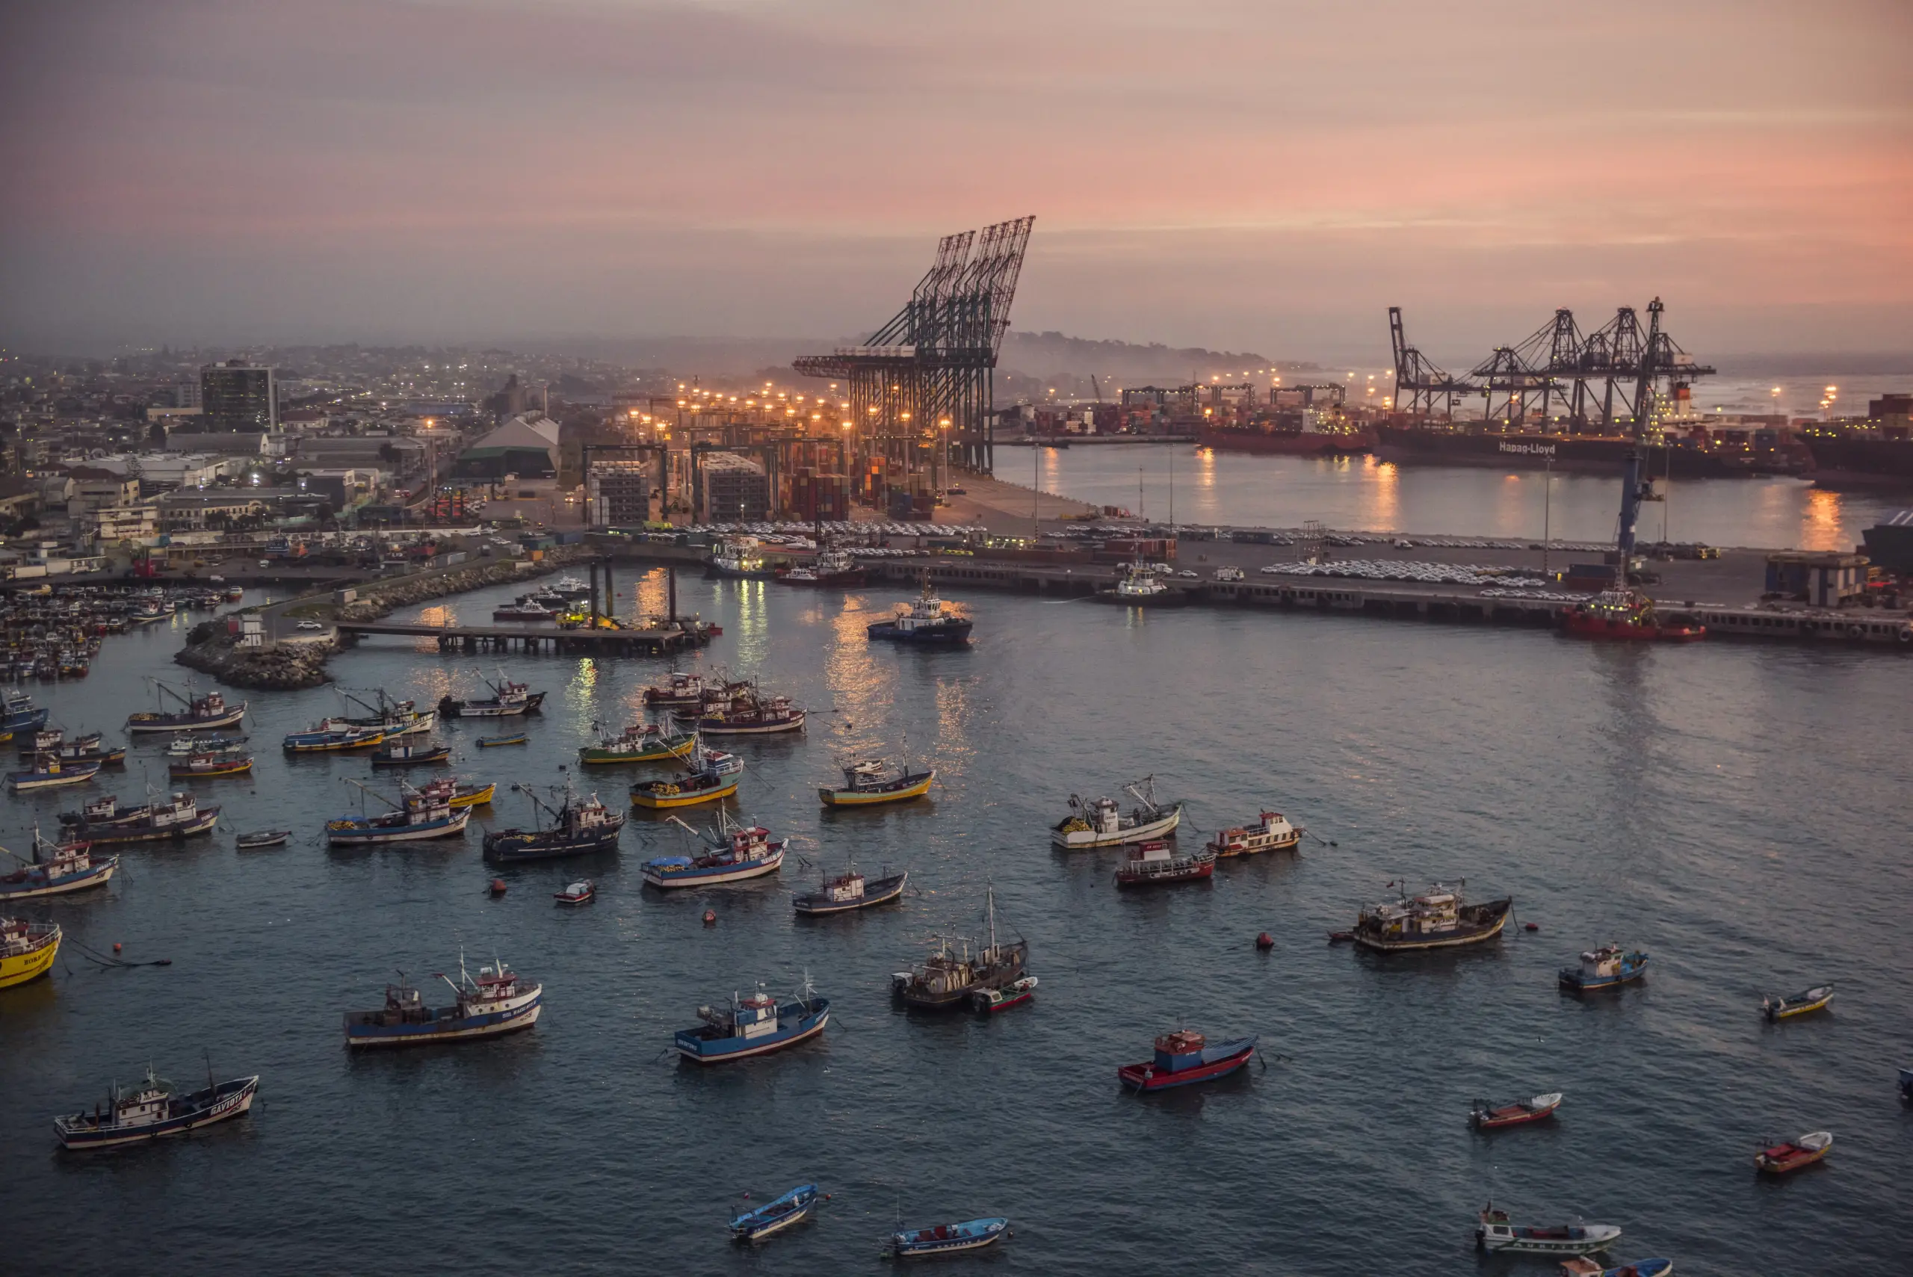
Author: Myles Kirby June, 2026
Overview
When Chinese President Xi Jinping personally inaugurated the Port of Chancay in November 2024, flanked by dignitaries from across Latin America, he called it a "new land sea corridor between China and Latin America." At the time, China’s commercial ambition was obvious, yet what the ceremony didn't advertise was the structural implications that have since become impossible to ignore.
Several hundred kilometers south, Chile is now at the center of the most consequential port infrastructure contest in the Western Hemisphere. Puerto Exterior, the $4.45 billion expansion of San Antonio that received unanimous environmental approval less than two weeks ago in May 2026, will be the largest port infrastructure project in Chilean history, while drawing a prequalified bidder list that reads as a map of competing geopolitical interests: Chinese state-owned enterprises, South Korean industrial giants, and a European construction bloc led by Belgian and Dutch dredging specialists. The United States, despite being Chile's largest cumulative foreign investor, is not on it.
This piece examines what Puerto Exterior reveals about how the contest for Latin America's logistics infrastructure is being fought, who is showing up, on what terms, and what the absence of certain players signals about the limits of Western strategy.
Section I

The infrastructure play: how Beijing came to own the supply chain
Chinese companies hold ownership or operational control over at least 14 ports across Latin America and the Caribbean, with construction involvement at a further 18. Scanning technology from Chinese state-linked firms has been installed at a minimum of five additional terminals where no formal Chinese operational footprint yet exists. These commercial transactions form a network exhibiting compounding strategic value, and the crown jewel of that network is Chancay.
Chancay:
• The first deep-water port on South America's Pacific coast capable of handling ultralarge container vessels of up to 24,000 TEUs, Operated exclusively by COSCO
• 79 per cent of customs declarations listed China as the destination (In its first full year)
• Shipping time between Lima and Shanghai dropped from 35 days to 23
o Freight costs fell by around 30 per cent.
• COSCO's projects 19,000 Chinese-manufactured automobiles moving through the terminal in 2026 (Primarily travelling to Chile, Ecuador, and Colombia).
• The port's new WSA5 route directly connects Shanghai and Qingdao to Colombia's Buenaventura o first transpacific service to linking Latam Pacific ports to China without transshipment
What makes Chancay strategically significant beyond its commercial performance is the model of control built into it from the start. COSCO pushed through amendments to Peruvian law during construction to secure exclusive operational status. Surveillance and scanning equipment from firms blacklisted by the US has been installed across the facility, and in the months since opening, the surrounding area has become one of Peru's most violent provinces, with extortion up 25 per cent since inauguration. Hence, this infrastructure ‘gift’ arrives as an institution that is hard to audit, hard to regulate, and structurally very difficult to depart from, which became visible when Peru's First Constitutional Court issued a ruling ordering the national transport infrastructure regulator, Ositran, to immediately cease exercising its supervisory, regulatory, and sanctioning powers over Chancay. The ruling upheld a constitutional protection claim filed by COSCO itself, making Chancay the only major public-use port in Peru entirely exempt from the oversight body that governs every other terminal in the country.

The Chancay precedent: what regulatory exemption means
The January 2026 ruling establishes that a Chinese state enterprise can operate critical national infrastructure on sovereign territory free from the oversight framework that applies to every comparable facility in the country, establishing the port as indispensable infrastructure, and consequently using the host country's legal system to remove the constraints.

China's footprint extends well beyond Peru. In Mexico, Hutchison Ports operates seven terminals across five strategic ports, Manzanillo, Veracruz, Lázaro Cárdenas, Ensenada, and Altamira, handling an estimated 35 to 40 per cent of Mexico's containerized cargo. In Colombia, President Petro signed a letter of intent to join the Belt and Road Initiative in May 2025, with his Historical Pact winning more Senate seats than any other party in March 2026. Colombia's Buenaventura port has already been incorporated into COSCO's WSA5 route, binding it functionally to the Chinese logistics network regardless of any future political change in Bogotá.

Section II

Panama and the limits of Western counter-strategy
Panama represents the most contested node on the maritime chessboard, and the most instructive case study in what Western counterstrategy can and cannot achieve. In early 2025, under sustained US pressure, Panama withdrew from the Belt and Road Initiative and filed suit against Hutchison after Beijing blocked the intended $23 billion sale of its canal-flanking terminals to a BlackRock-led consortium. The sale remains locked in litigation, with COSCO now reportedly seeking a stake in the same 43-port portfolio, meaning Beijing could end up with more influence over regional infrastructure than before the challenge began.
Japan has moved more constructively into this space. A $2.6 billion government-backed loan is financing Panama City's Metro Line 3, including a 5-kilometre tunnel beneath the canal, built by a Hitachi-Mitsubishi consortium due to open in 2028. The Panama Canal Authority has simultaneously announced two new port terminals targeting an expansion in capacity from 9.5 million to 15 million TEUs annually. Tokyo's foresight extends beyond commercial logic, as the deliberate infrastructure offer to a country recently extracted from China's column, demonstrates that Western capital can compete when properly organized and state backed.
Section III

Puerto Exterior: sovereignty as competitive advantage
Two weeks ago, in May 2026, Chile's environmental review authority granted unanimous approval to Puerto Exterior, the Outer Port expansion at San Antonio, cementing it as the largest port infrastructure project in Chilean history. The $4.45 billion scheme will triple San Antonio's cargo capacity to six million TEUs annually. Critically, the investment structure is not a straightforward foreign concession, but rather a mixed public-private model in which the Chilean state, through EPSA, retains structural authority over the project's architecture, timelines, and regulatory conditions.
That private concession pool design of this project reflects a deliberate and instructive strategic choice. EPSA structured the international prequalification process to force the world's leading maritime construction powers to compete directly against one another, and consequently the bidder list that emerged maps the global contest for Latin American infrastructure with unusual clarity.
China entered through two state-owned giants. China Harbour Engineering Company (CHEC), a subsidiary of China Communications Construction Company and Beijing's primary vehicle for deep-water port construction globally, prequalified for the core terminal infrastructure. China Railway Construction Corporation (CRCC) entered specifically for the breakwater, dredging, and integrated rail access network, the enabling backbone of the entire project. For China, a footprint at San Antonio would give its state firms unparalleled leverage over the two most critical maritime exit points for South American minerals, lithium, and agricultural goods heading to Asia. The totally and implications of this leverage are not on the same scale as Chancay, however it does illustrate China’s strategic grip on the Pacific corridor.
Europe's response has been more fragmented but substantively present. Belgium's Jan de Nul prequalified early, deploying its specialist heavy-vessel fleet for the deep-sea breakwater and channel dredging, the most technically complex element of the project. The Acciona-DEME consortium, pairing Spain's Acciona with Belgium's DEME Group, positioned itself as the European governance alternative: emphasizing strict environmental standards and smart infrastructure credentials as a direct contrast to Chinese state-subsidized bids. Van Oord of the Netherlands entered separately, bringing comparable dredging capability and an established Latin American track record. South Korea's Hyundai Engineering and Construction completed the field, driven by Seoul's direct strategic interest in securing supply chain resilience for its copper and lithium-dependent technology and electric vehicle battery industries.
The legal foundation for this approach is Chile's Ley de Modernización Portuaria: Law 19.542, which establishes the competitive concession structure that made this kind of structured international rivalry possible. Unlike the no-bid renewals that entrenched Hutchison in Panama, or the constitutional workarounds that removed Ositran's authority over Chancay, Chilean port law requires open international competition, mandates regulatory oversight, and preserves state authority over the infrastructure's fundamental conditions. The contrast with Peru is not incidental, as it was specifically engineered that way.

The Puerto Exterior model: what Chile got right
By forcing China, Belgium, South Korea, the Netherlands, and Spain into direct competition under Chilean law, EPSA secured access to the world's most advanced port construction technology and most competitive pricing, without relinquishing operational sovereignty, regulatory oversight, or the right to set the terms of any future concession. Puerto Exterior received the foreign capital and expertise that Peru sought at Chancay. It did so without the Chancay conditions attached, due to Chile’s intentionally constructed legal architecture.

What Puerto Exterior also makes plain is where the United States sits in this contest (and where it does not). Despite being Chile's largest source of cumulative foreign direct investment, the US is absent from the prequalified list. American capital in Chile concentrates in high-value service sectors, clean energy, and digital infrastructure: Google's data centers, Pfizer's research facilities, renewable energy grids. US private firms do not naturally compete for massive civil engineering concessions. They are not organized to, partially because of the lack of state-backed funding. This is not a failure of interest, rather it is a structural feature of how American capital allocates itself, and it leaves a consistent gap in the physical infrastructure space that Chinese SOEs are built precisely to fill, a time when supply chain leverage and raw material transportation is only becoming more pertinent.
Washington's engagement with China's Latin American logistics network under the Trump administration is defined by rhetorical assertiveness and structural underinvestment. Declaring China's hemispheric port presence unacceptable, through Monroe Doctrine framing, Chancay warnings, and Panama pressure, is not an infrastructure strategy. The Development Finance Corporation has sent assessment delegations to San Antonio, explicitly framing the engagement as a Chancay counter. But the DFC remains at the assessment stage while the Puerto Exterior tender moves toward July 2026 offers.
The structural problem is institutional. A private US construction or shipping company competing for a Chilean port concession does not carry the implicit backing of the US Treasury, does not benefit from below-market state lending, and does not arrive with a government-to-government relationship already in place. COSCO is the Chinese state in commercial form. American private capital is not organized that way. The US advantage in Chile is real, in FDI depth, bilateral trust, and shared security architecture, but it is concentrated in sectors that do not compete with Chinese SOEs at the tender stage.
Section VI

Infrastructure entry points: three approaches compared

The Chinese approach: state capital as strategic instrument
CHEC and CRCC arrive at Puerto Exterior with all the advantages of state backing: below-market financing through Chinese policy banks, government-to-government relationship infrastructure already cultivated across the region, and a portfolio of completed deep-water port projects from Chancay to Sri Lanka to West Africa that constitutes genuine technical credibility. Their bids will likely be the most price competitive. The question Chilean authorities must weigh, and the question that the Chancay precedent has now made impossible to ignore, is what that pricing actually buys, and on whose terms the infrastructure will eventually operate.

The European approach: governance as differentiator
Jan de Nul, Van Oord, and the Acciona-DEME consortium represent a different offer: technically credible, commercially structured, and explicitly positioned around European environmental and governance standards as a selling point rather than a compliance cost. This is not purely altruistic, European firms need the revenue and the reference project, but it aligns with what Chilean port authorities and an increasingly attentive US Treasury are looking for: operators who can be regulated, audited, and held to account under Chilean law. The Acciona-DEME consortium's "green infrastructure" framing is a direct read of the political moment. Whether it translates into commercial advantage depends on how much weight EPSA ultimately places on governance credentials versus price.
For the UK, the European firms' presence at Puerto Exterior is both an opportunity and a warning. British logistics operators, port technology firms, and export finance institutions are not in this field. The construction tender is now largely set. The Terminal Mar operating concession, the long-term management contract, does not open until 2030. That window exists, but it requires organized engagement now, not in 2029. UK firms with relevant capability in port management, digital logistics systems, and cold-chain infrastructure, should be building relationships with EPSA and Chilean exporters today, using the CPTPP framework and UKEF capacity that no European competitor currently holds in equivalent form.

The US approach: deep investment, wrong sectors
The United States remains Chile's largest cumulative FDI source, but its capital concentrates where Chinese SOEs do not compete services, clean energy, digital infrastructure. DP World's July 2025 launch of the ACSA 1 route, a weekly direct service connecting San Antonio with Shanghai, Ningbo, and Busan, represents genuine US-aligned commercial presence at the port. The DFC's San Antonio engagement, if it moves from assessment to commitment, could shift the picture at the Terminal Mar concession stage. But the structural reality is that American private capital does not enter the heavy civil engineering space that Puerto Exterior's construction phase requires. In the near term, the US presence at San Antonio will be felt through shipping services and diplomatic support rather than infrastructure equity, a meaningful role, but not necessarily indespensible.

Final thoughts

Puerto Exterior and the terms of the contest
Puerto Exterior is, at its core, a test of whether the lessons of Chancay have been learned, not by Chile, which structured its procurement precisely to avoid the Peruvian outcome, but by the Western powers that claim to be alarmed by what Chancay represents.
Chile has done its part. Ley 19.542 created the competitive framework, while the unanimous environmental approval of May 2026 cleared the final institutional hurdle. EPSA's prequalification process forced a genuine international contest, resulting in a $4.45 billion project that will be built. However, the questions surrounding who build and operate the port, and the extent of the regulatory conditions will be answered by the technical and economic offers due in July 2026, and by the Terminal Mar operating concession that follows in 2030.
The Chancay model, build, embed, exempt, worked because Peru's institutional architecture codified to resist and regulate such large-scale foreign investment, and because no credible Western alternative appeared at the critical moment. At Puerto Exterior, the institutional architecture is stronger: Chilean law, EPSA's structured competition, an environmental process that took years and withstood serious scrutiny. But institutional strength is a necessary condition, not a sufficient one. It creates space for a genuine contest, while not guaranteeing a winner.
European firms are in that contest. Chinese state firms are in it. South Korean industrial capital is in it. Japan has demonstrated in Panama that state-backed Western infrastructure financing can move decisively when organized. The United States is watching from the assessment stage. The UK is, to date, absent from the construction tender and unorganized for the operating concession.
What Puerto Exterior ultimately reveals is that the battle for Latin America's logistics infrastructure is not being lost to Chinese superiority. It is being ceded by Western disorganization, by the persistent gap between the geopolitical concern and the commercial commitment needed to address it. Chile has built the arena and the contest is live. The offers are due in July.

